**Final Project**

**Setting up the local environment**

Install the necessary application on the local environment

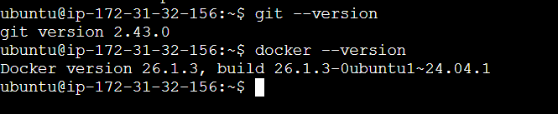

Clone the repository

git clone <https://github.com/sriram-R-krishnan/devops-build\>

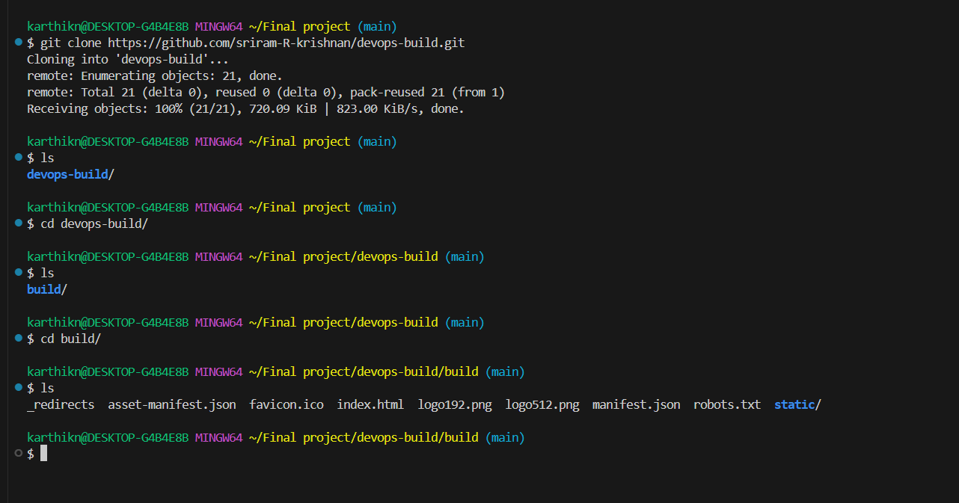



**To create a dockerfile**

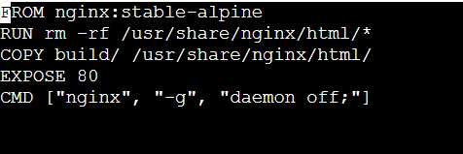

**Docker image**

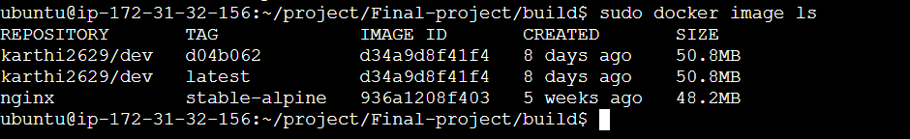

dockercompose.yml

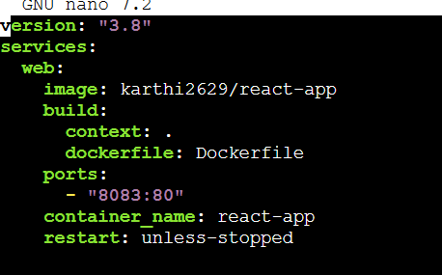

**Bash Scripting**

Build.sh

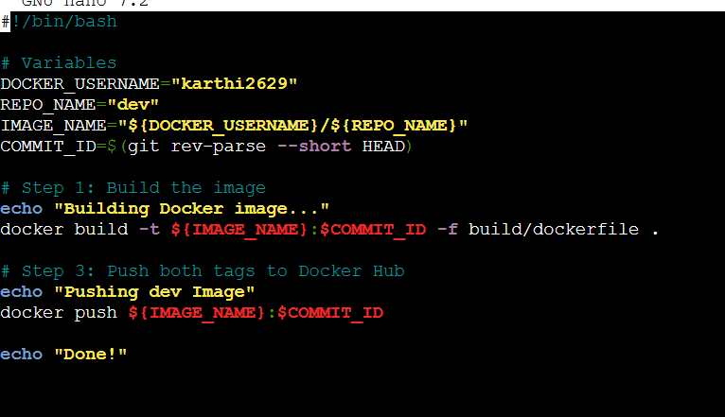

Deploy.sh

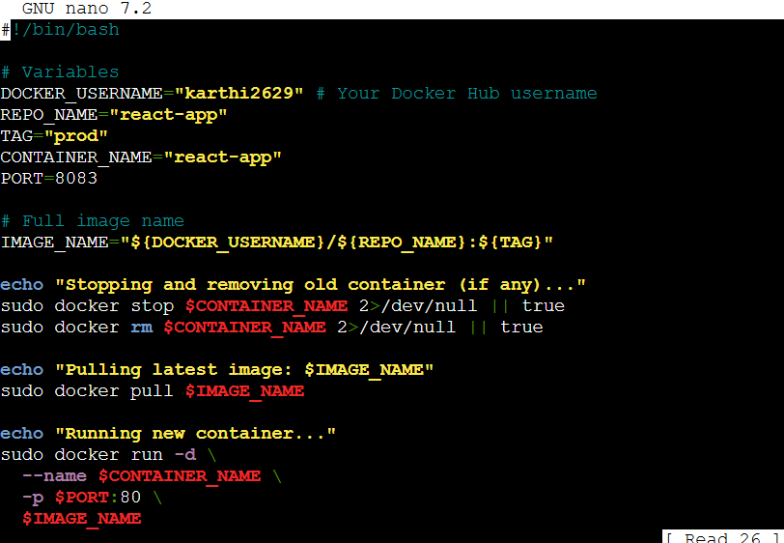

**Docker Hub (Build.sh script will build the docker image and push it to docker hub (dev and prod tags))**

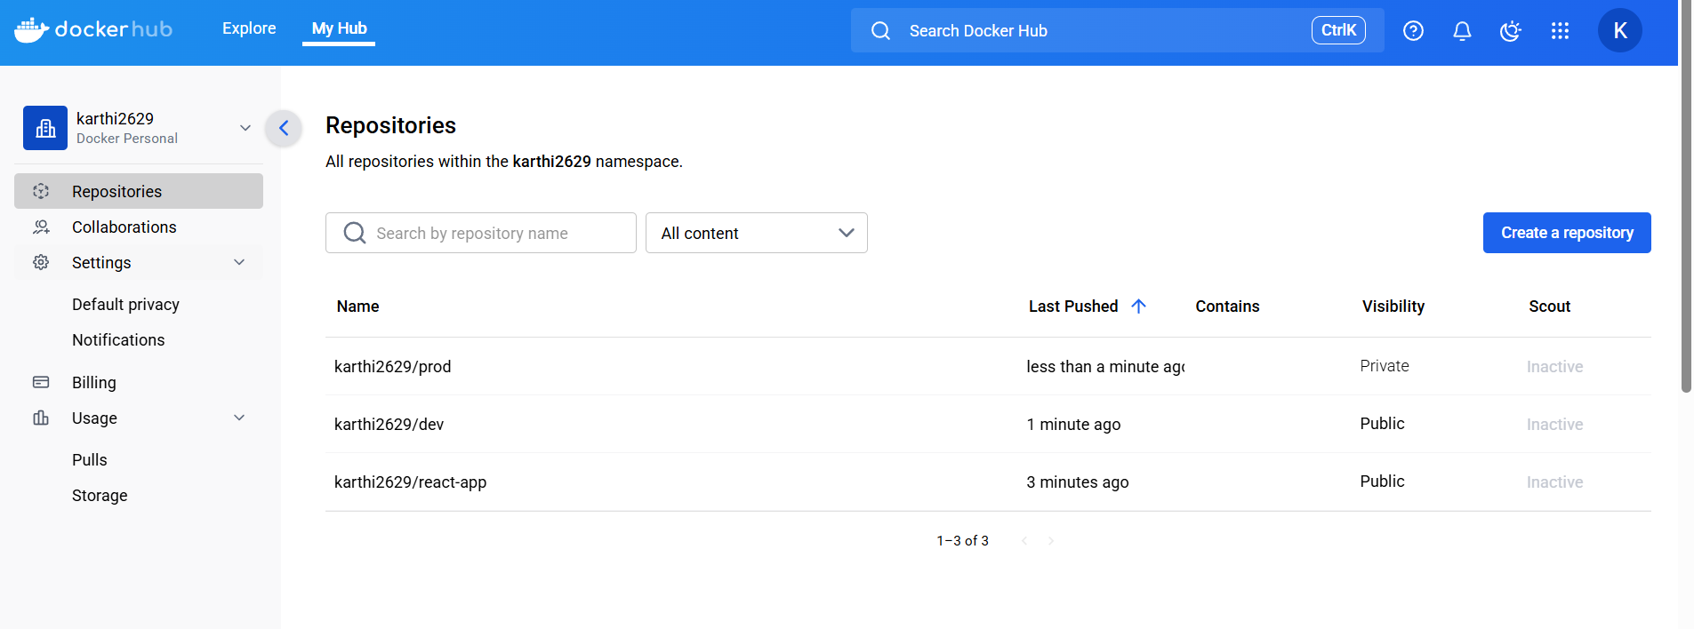

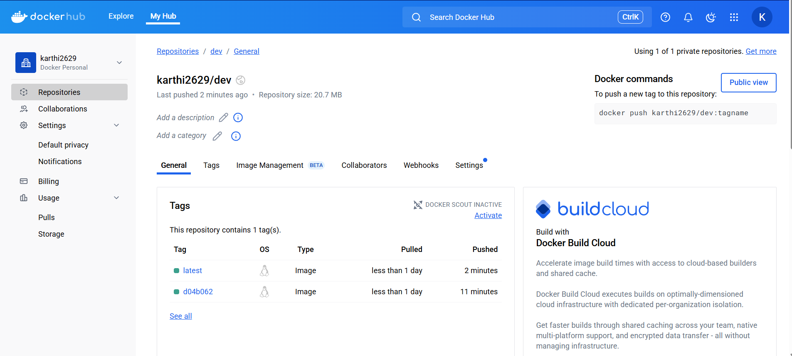

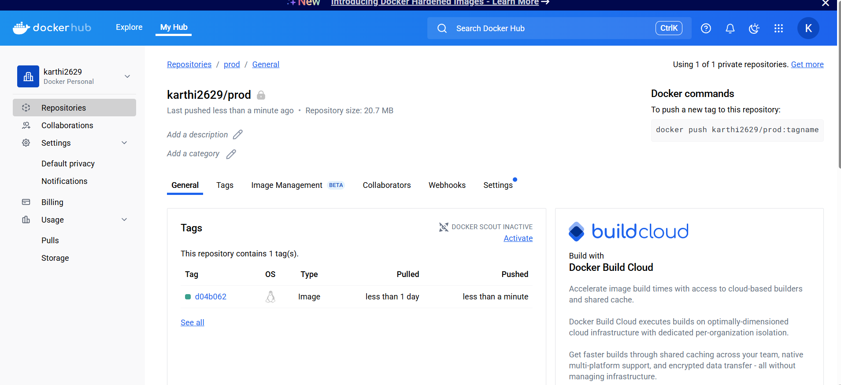

**Jenkins**

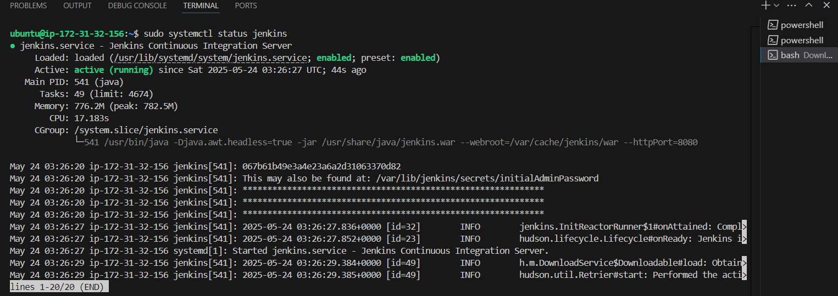

Webhook:

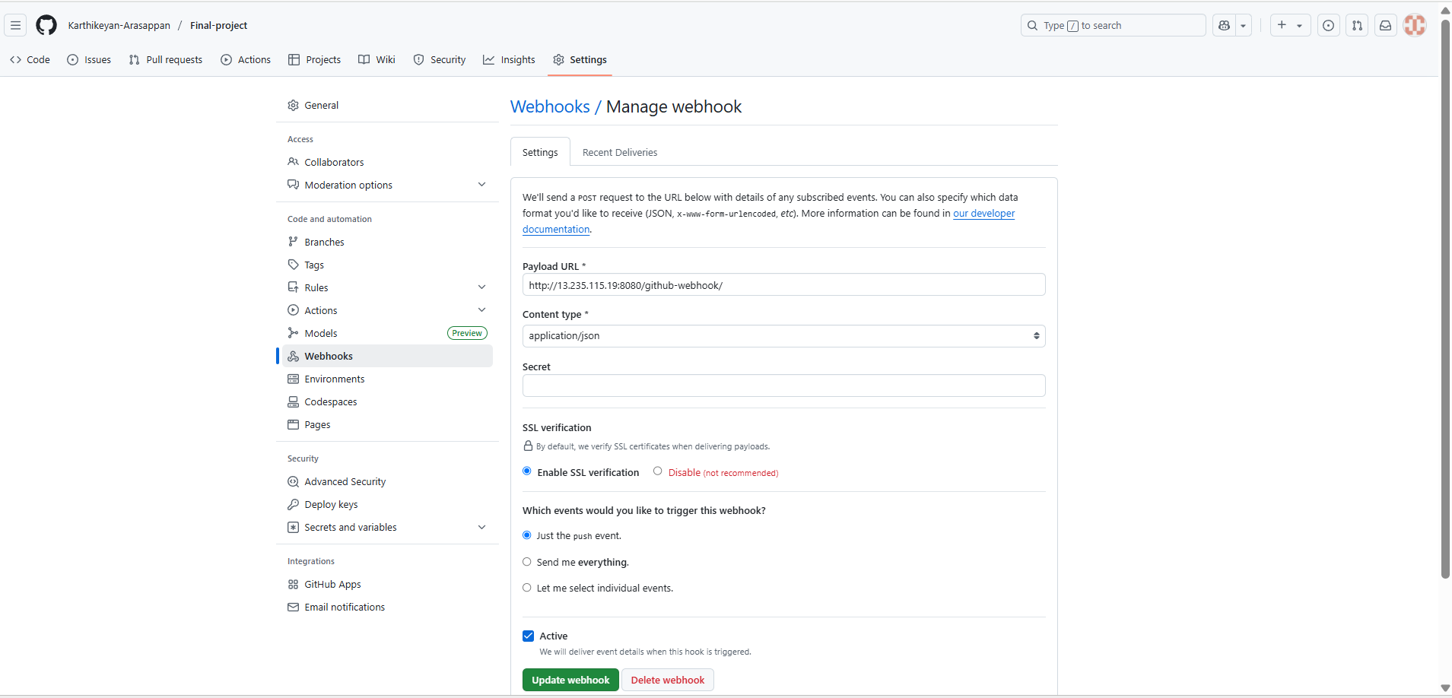

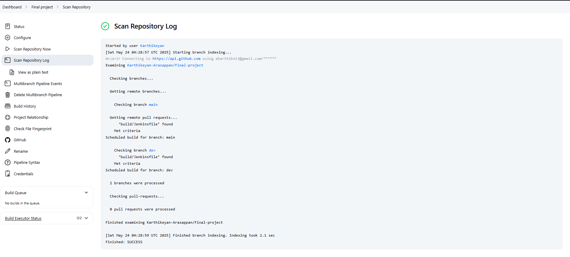

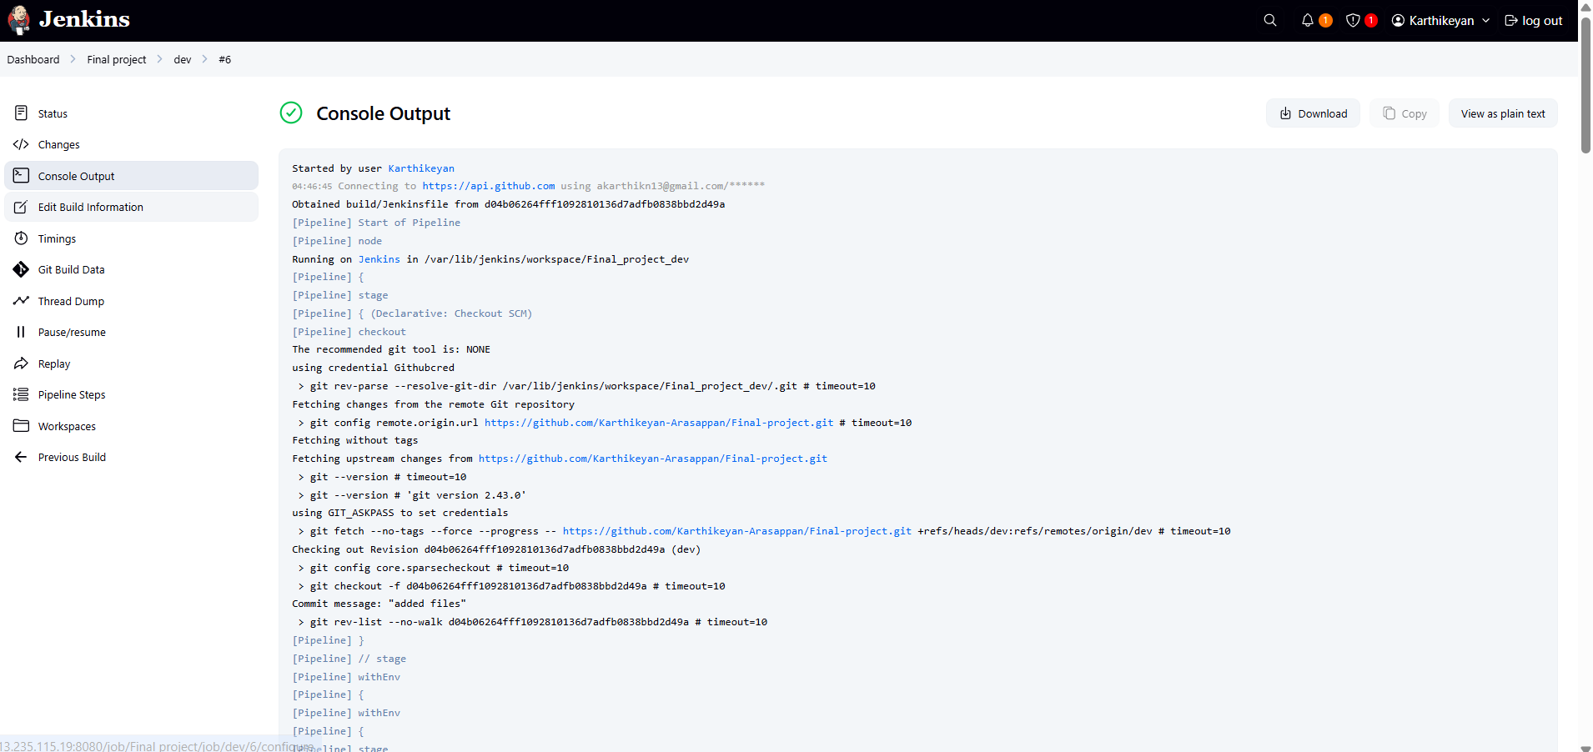

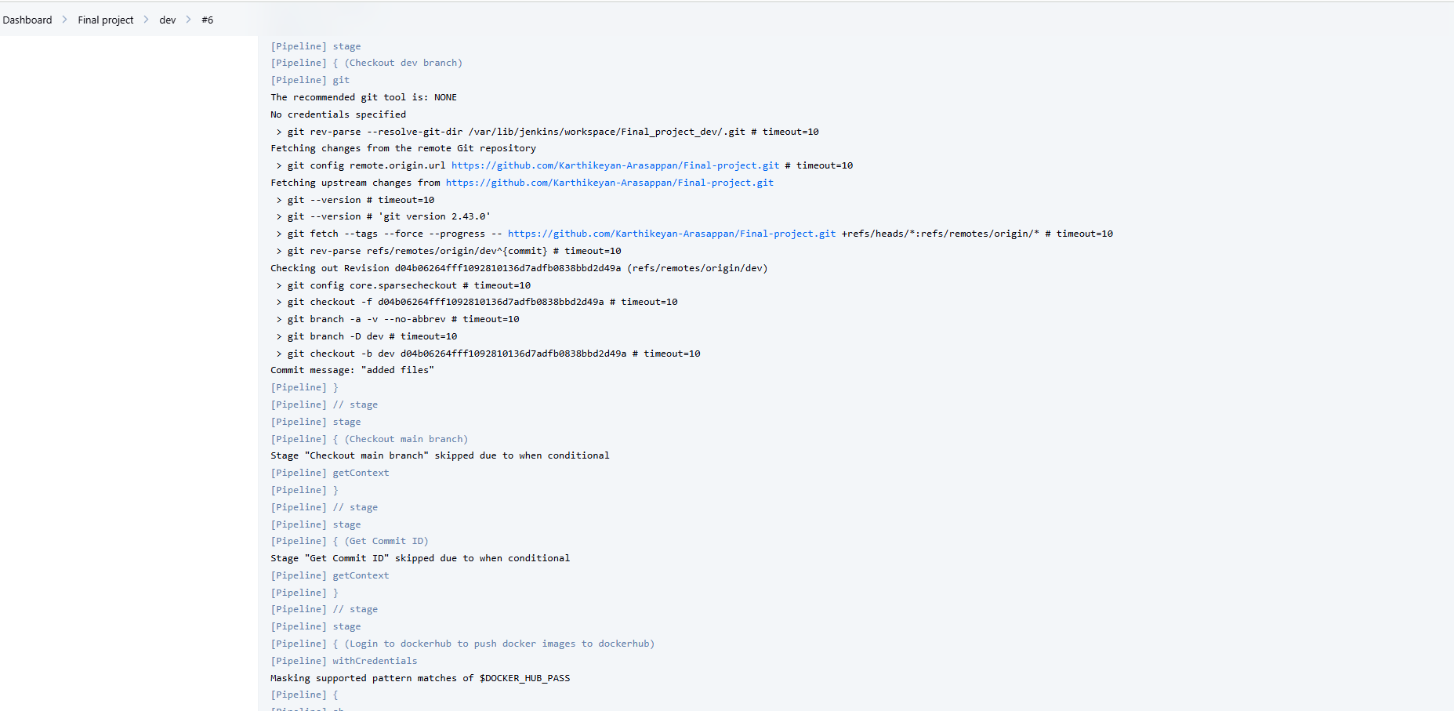

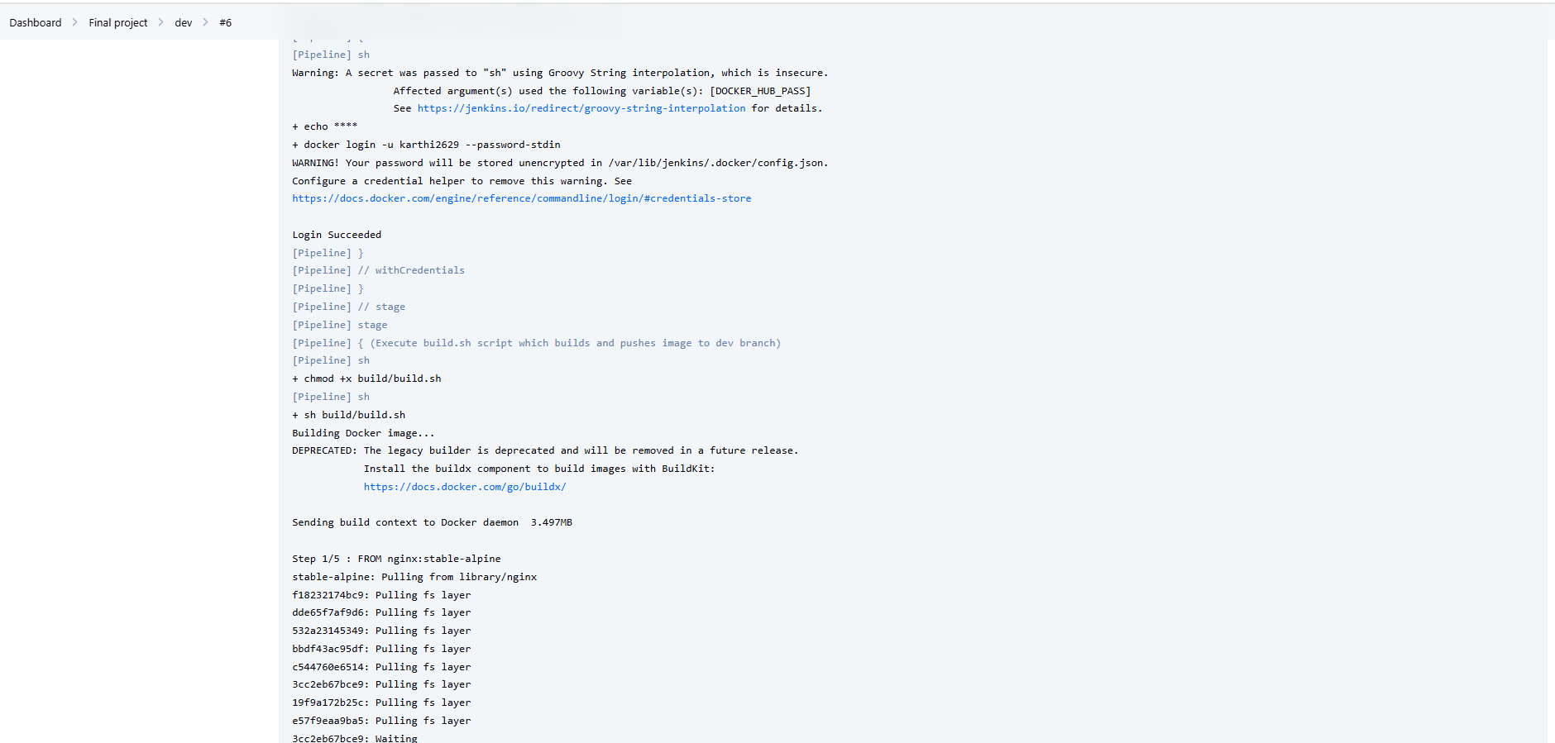

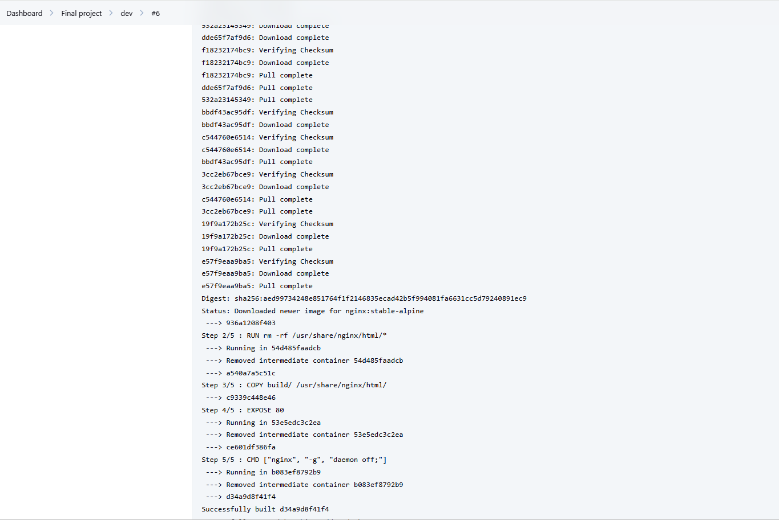

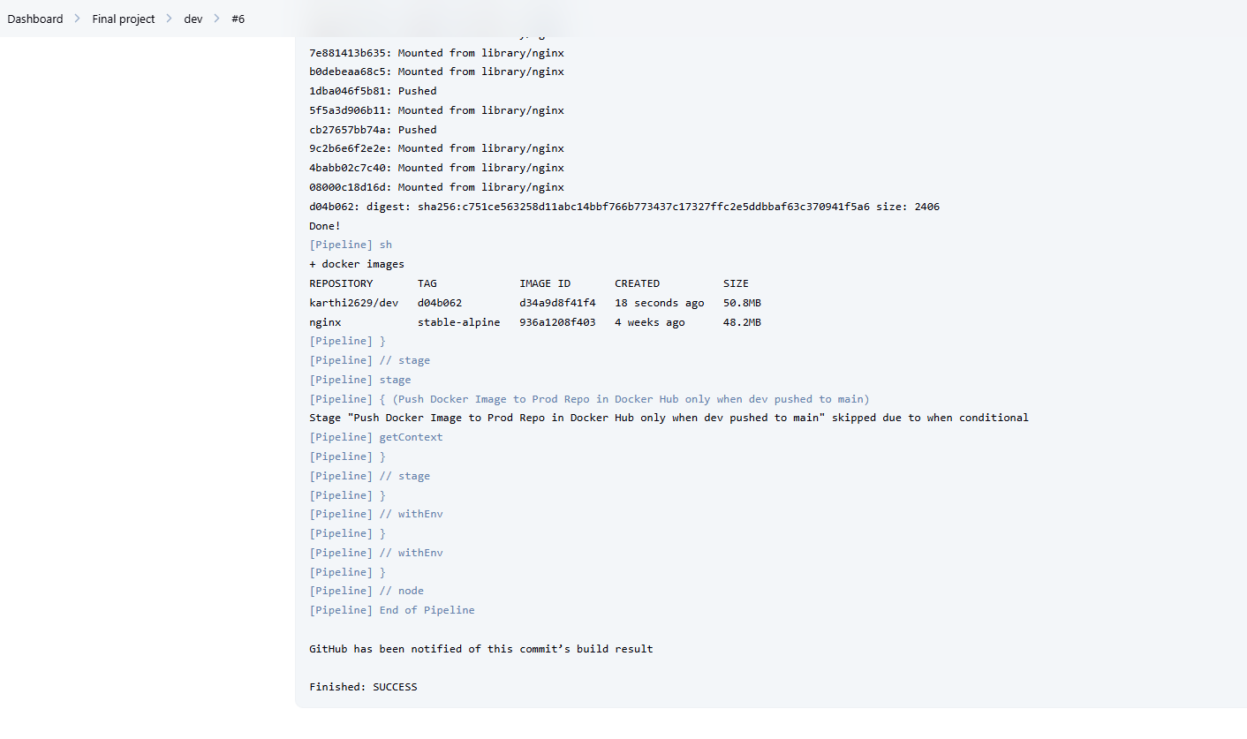

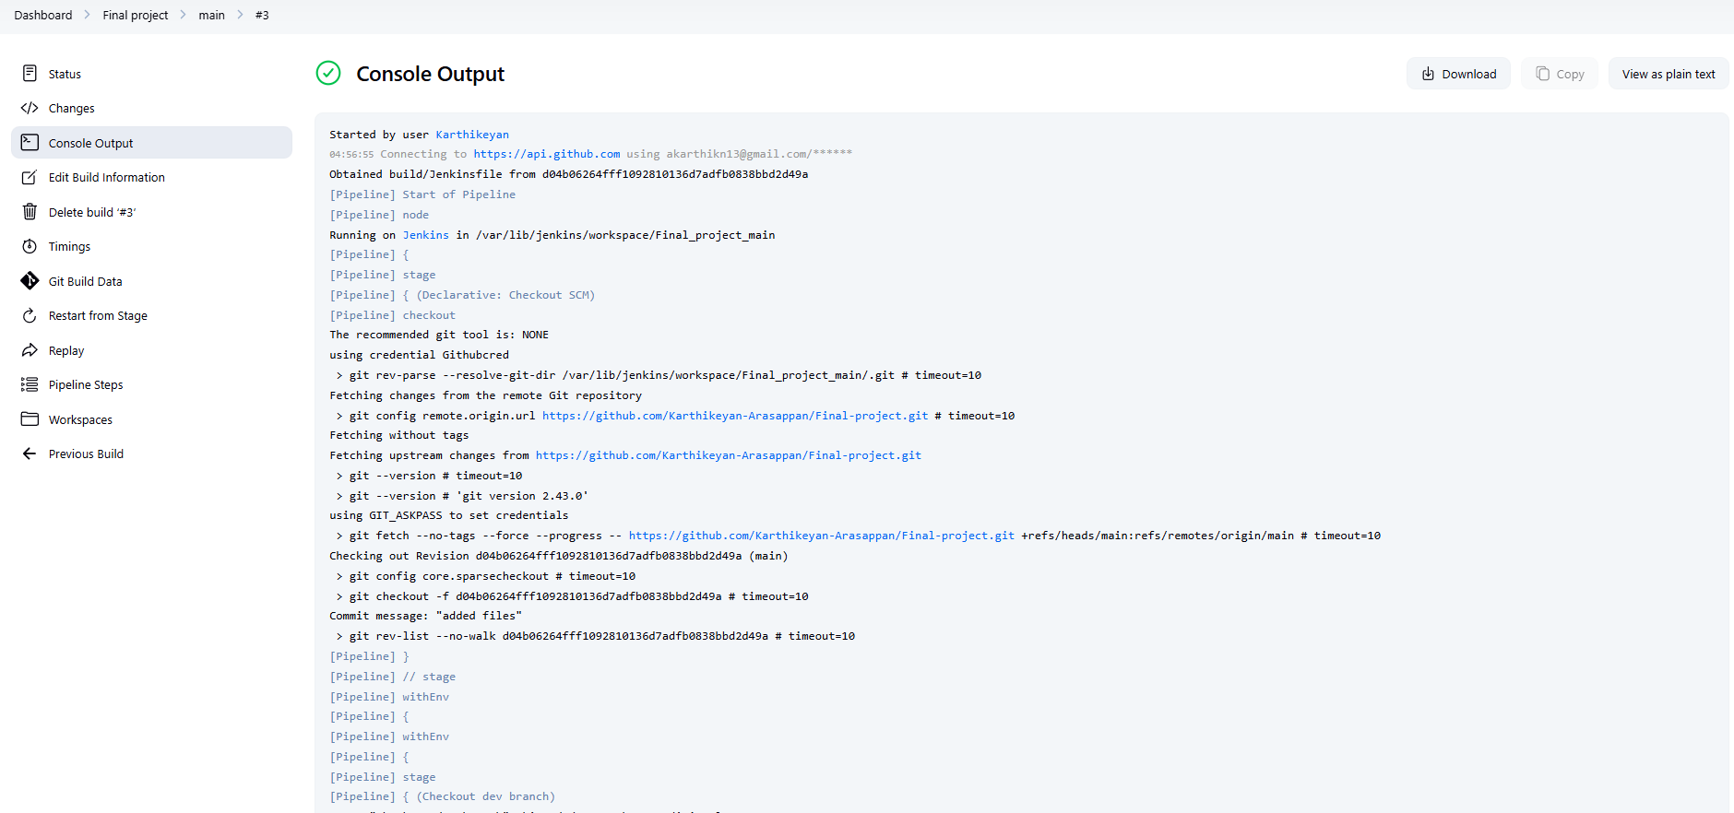

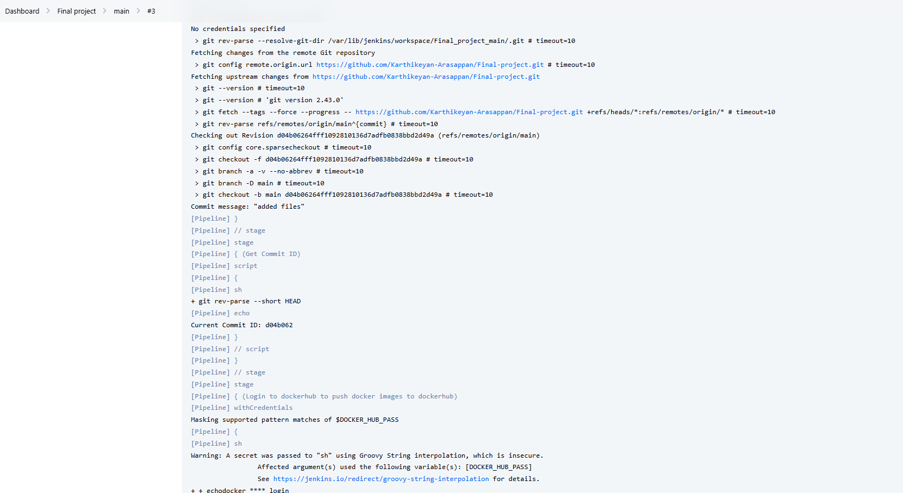

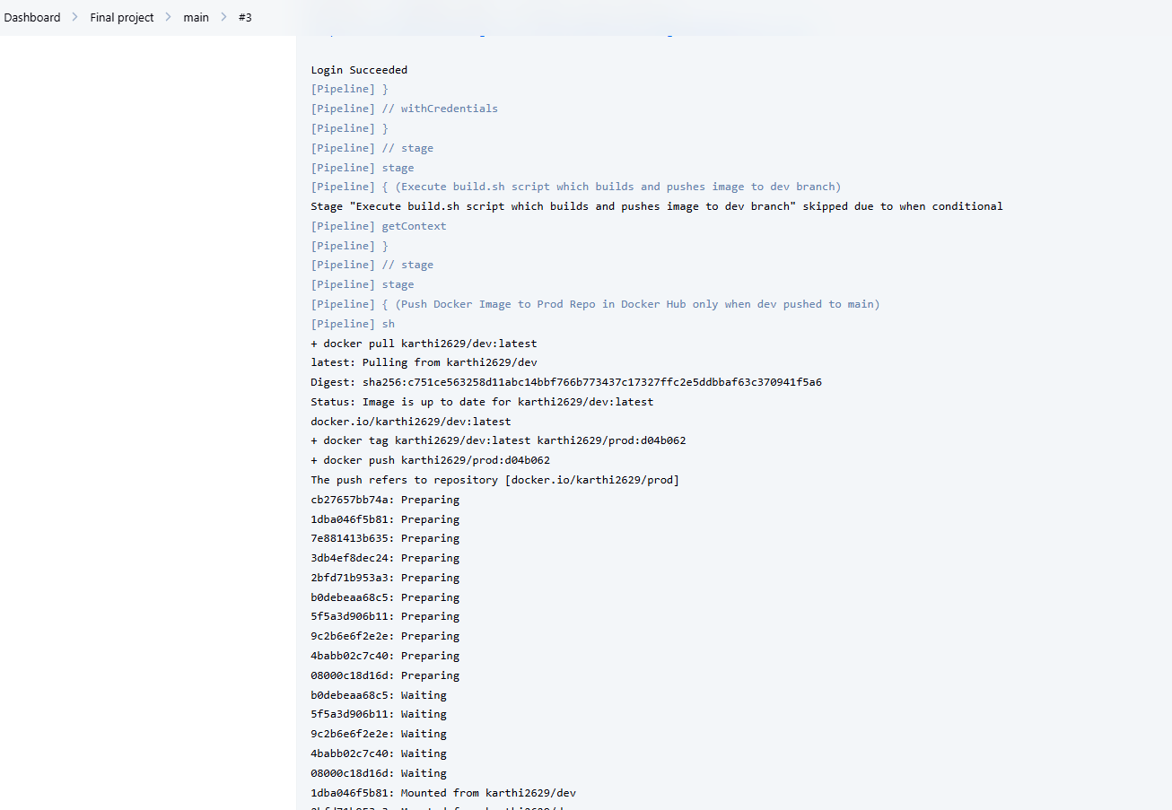

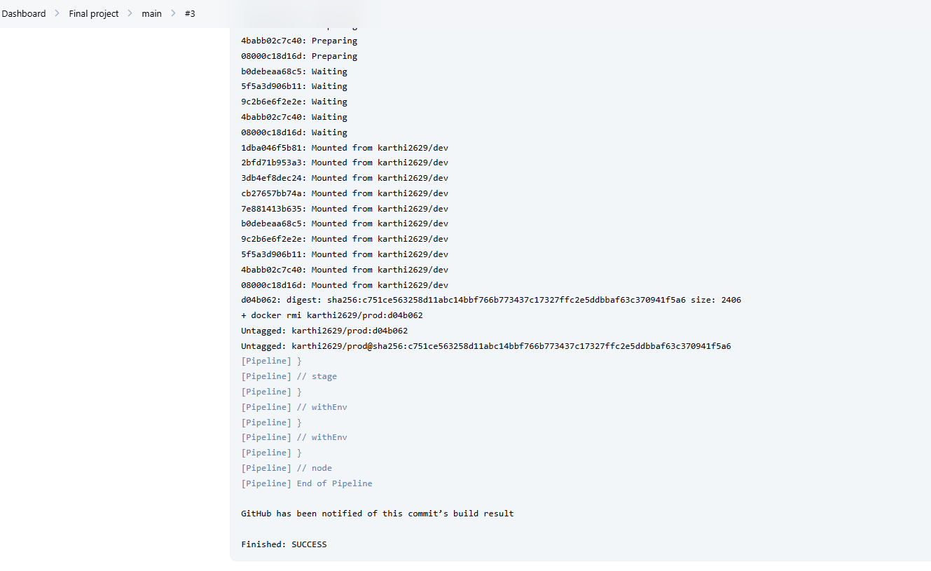

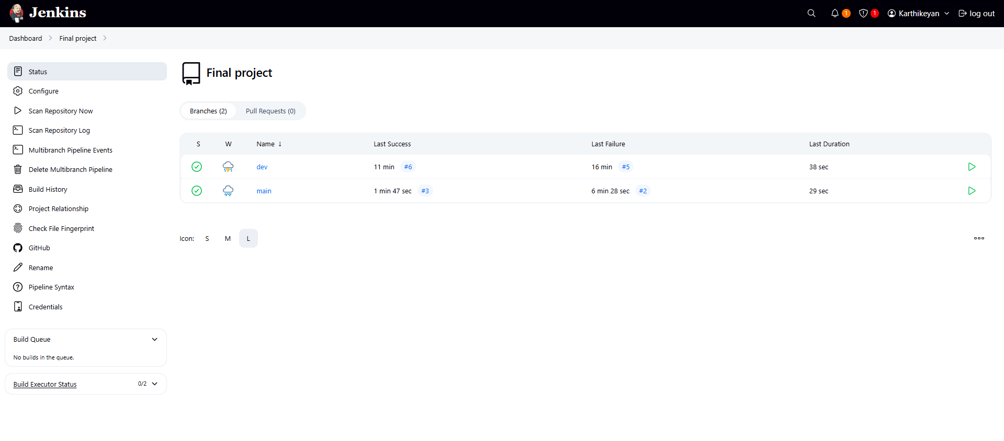

**Setup Monitoring for react-app**

**sudo useradd --no-create-home --shell /bin/false Prometheus**

**wget https://github.com/prometheus/node_exporter/releases/download/v1.7.0/node_exporter-1.7.0.linux-amd64.tar.gz # Check for latest version**

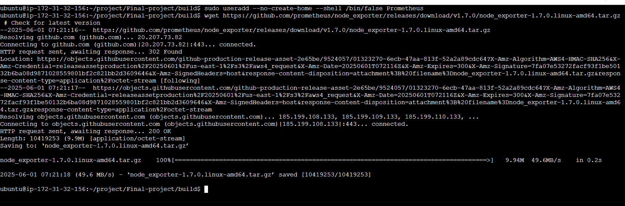

**tar xvf node_exporter-*.linux-amd64.tar.gz**

**sudo mv node_exporter-*.linux-amd64/node_exporter /usr/local/bin/**

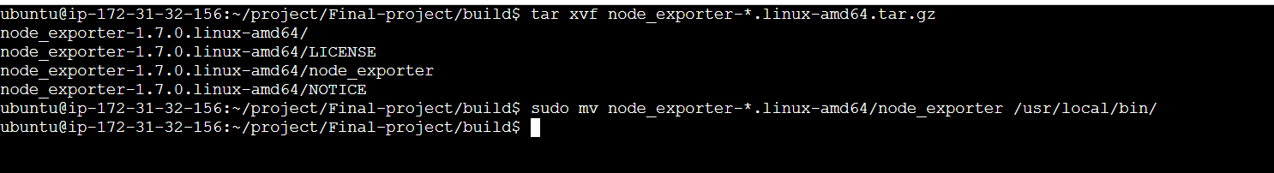



**Install Prometheus on the EC2 Instance**

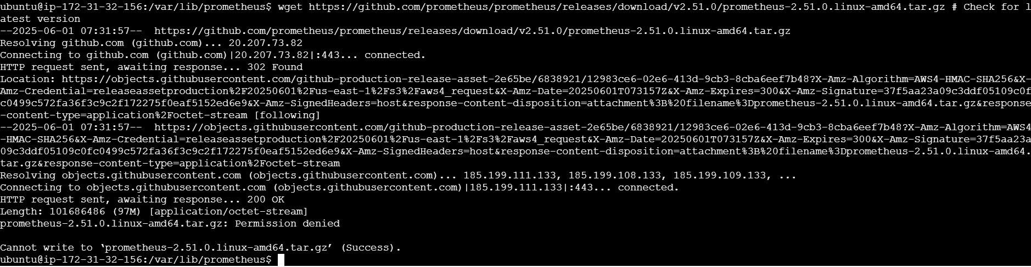

**Install Grafana on the EC2 Instance**



